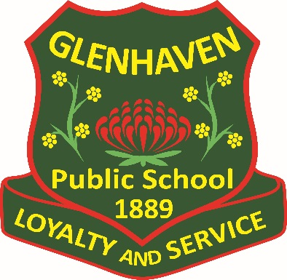

DISCIPLINE AND WELL-BEING POLICY

GLENHAVEN PUBLIC SCHOOL
74A Glenhaven Road, Glenhaven, NSW 2156
Ph. (02) 96343675
E. glenhaven-p.school@det.nsw.edu.au
Discipline and Well-Being Policy

Education has an important role to support children and young people and to identify where problems arise that may put their safety, welfare or well-being at risk. Glenhaven Public School provides a safe and supportive environment for the whole community where academic achievement is encouraged and the uniqueness, personality and talents of the individual are valued and developed in an atmosphere, which fosters tolerance, kindness and respect.

This policy was developed to provide information on student wellbeing and outline the processes and expectations of student discipline. It has been written in conjunction with the Well-Being Framework for Schools and Student Discipline in Government Schools Policy form the Department of Education.

Contextual Statement

Glenhaven Public School endeavors to promote, for all students and staff, a healthy, safe, ordered, supportive, secure and caring environment, which is conducive to teaching and learning. We aim to help students to become self-directed, life-long learners who can create a positive future for themselves and for the wider community. Schools need to establish clear guidelines and expectations in regards to the rights and responsibilities and behaviors which are known and understood by all community members. At Glenhaven Public School we believe that our school is a place where each student can learn and grow in confidence.
Student welfare encompasses everything that the school community does to meet the personal and social needs of the students and to enhance their wellbeing. It involves recognising, valuing and developing each student as a total and unique person in the context of society. Student wellbeing is enhanced when all members of the school community participate in the learning programs and life of the school.

As a Positive Behavior for Learning School, Glenhaven Public School has developed a statement of core values that underpin the wellbeing of all students.

These core values to support the code of behavior are:

Wellbeing
The New South Wales Department of Education is committed to creating quality-learning opportunities for children and young people. This includes strengthening their cognitive, physical, social, emotional, and spiritual development. Parents entrust their children and young people to principals, teachers and school staff with confidence that schools will deliver on this agenda.

The school environment, and the world in which our children and young people will grow and function, continue to change. Glenhaven Public School aims to be responsive to numerous influences as we deliver quality education now and in the future. There is a heightened awareness of, and commitment to, personalised and differentiated learning and support for every students to succeed.

Wellbeing is subjective to each individual and can be described as the quality of a person’s life which combines feeling good and functioning well. Wellbeing needs to be considered across all domains.

- Cognitive wellbeing is associated with achievement and success. It includes how information is processed and judgements are made. It is also informed by motivation and persistence to achieve. Cognitive wellbeing is important for attaining knowledge and experiencing positive learning
- Emotional wellbeing relates to self-awareness and emotional regulation. It includes how well we cope, and is often reflected by the level of a person’s resilience. Emotional wellbeing is in part informed by our capacity for self-refection.
- Social wellbeing includes the extent to which we experience positive relationships and connectedness to others. It is important for pro-social behavior and our empathy towards others.
- Physical wellbeing is associated with the extent to which we feel physically safe and healthy. It includes nutrition, preventative health care, physical activity and physical safety and security. Physical wellbeing enables health outcomes.
- Spiritual wellbeing relates to our sense of meaning and purpose. It can include our connection to culture, religion or community and includes the beliefs, values and ethics we hold.

At Glenhaven Public School these domains are addressed through programs such as Peer Support, Positive Behaviour for Learning, Assembly and Values Awards, Games Room, Drug Education, SRC, Life Education and Scripture. By educating our students through these programs, we are able to promote a positive wellbeing system.

Classroom teachers have their own reward system to suit the specific needs of their classrooms and students. This system involves both verbal and written praise, which aims to increase intrinsic motivations as the year progresses. These Classroom Plans are developed at the beginning of each year and form an integral part of the teacher’s teaching and learning program.

At Glenhaven Public School, we endeavor to provide a happy, positive and safe learning environment which all students apply themselves to learning and develop positive social behaviours and problem thinking skills. In turn, our students will be expected to contribute to their own wellbeing, the wellbeing of their peers and the collective wellbeing of their communities. In doing so, students will become active and positive contributors to the society in which they live.

Learning and Support.

Glenhaven Pubic School is committed to providing personalized and differentiated learning and support for students with identified learning needs to give each student the opportunity to succeed. Adjustments to the learning environment are made and documented as required. These students are identified by staff and are provided with additional support through the learning and support team. Parents are consulted and given the opportunity to contribute to the planning to support their child’s individual learning.

A Personalised Learning and Support Plan - PLaSP is a working document, designed by teachers in collaboration with stakeholders, which informs the planning, delivery and evaluation of an educational program. It is required to provide additional support or an alternative or modified program, environment or curriculum. Students requiring a PLaSP are selected by teachers and are updated each semester and signed by the parent/carer and classroom teacher. These may be updated and monitored more frequently when required after consultation. Evidence to support this plan is gathered throughout the year, and then used to inform and support the National Collection of Disability Data each year.
All Aboriginal and Torres Strait Islander have an individualised Personal Leaning Plan (PLP) which is updated each Semester and signed by the parent/carer and classroom teacher.

Other services and resources Glenhaven Public School has for learning and support include:
- School Counselling Service
- Student Learning Support Officers
- Trained parent/ community workers I Multi-Lit and Spelling Mastery
- Anti-Bullying Plan
- Learning and Support Teacher LaST.

Health Care Plans

Students with identified health care needs are required to have an individualised health care plan. Planning must take into account the student’s full range of learning and support needs. This is developed in consultation with the parent, staff and student, where practicable, and on the basis of information from the student’s doctor, provided by the parent. This must be provided to the school by the parent/carer and updated at least annually.

Health care plans are required for students:
- Diagnosed with asthma, type 1 diabetes, epilepsy or anaphylaxis
- Diagnosed as being at risk of an emergency
- Who require the administration of health care procedures.

Principals are required to:
- Assist students who have health support needs at school
- Have systems in place to collect health information about students at enrolment and on a regular basis
- Collect and record the immunisation status of students at enrolment
- Have systems in place to protect the health and safety of all students when they are at school or involved in school activities
- Provide temporary care when a student becomes unwell at school, which may include the provision of first aid (including emergency care)
- Report cases of vaccine preventable diseases, as listed on the student health website, to the local public health unit
- Attempt to avoid the use of peanuts, tree nuts or any nut products in curriculum or extracurricular activities. This does not include food labelled as "may contain traces of nuts".

Learning and Support Flow Chart

Successful program
Successful program

Rights and Responsibilities
Students learn most effectively in a positive, safe and calm environment. Our discipline system has been designed to ensure this outcome is achieved. Glenhaven Public School aims to have clearly defined rules, rewards and procedures, which will allow students to develop ownership of their behavior.

The Principal:
- Provides leadership and direction to the Discipline and Well-Being Policy and works closely with the school community including staff, students ,parents and caregivers, District office personnel and the NSW Department of Education along with the community agencies and other government bodies
- Encourages an atmosphere which allows students to achieve their personal best while learning together
- Provides support in programs related to student behaviour and attendance
- Takes appropriate and immediate action in situations where serious student behaviour concerns occur
- Presents special awards and provide publicity for the Well-Being and Discipline Policy as needed
- Supports all staff in the management of student behaviour
- Ensures procedural fairness
- Provides and support access to ongoing professional learning for staff.

The Assistant Principal:
- Supports the Principal in providing leadership and direction to the Discipline and Well-Being Policy
- Ensures procedures and policies are followed by staff
- Provides leadership and direction within their stages and across the school
- Encourages a school climate conducive to providing the ultimate in a student’s physical, psychological, emotional and educational welfare
- Provides support in Student Wellbeing matters involving students and/or parents and caregivers
- Provides support for teachers in managing difficult student behaviour
- Determines and implements appropriate logical consequences with the classroom teacher for inappropriate student behaviour and ensuring procedural fairness
- Is responsible for overseeing the teaching and learning programs in the school
- Assists in the establishment of a safe, healthy, clean school environment
- Provides staff support and the opportunities for professional development in the domain of Student Well-Being
- Assists students to reflect on their own behaviour and the consequences for their actions
- Communicates issues of student behaviour to staff
- Liaises with parents and the community in regard to student behavior.

The Teacher:
- Demonstrates professionalism and commitment to teaching
- Develops and maintains effective classroom management practices
- Models and explicitly teaches desired student behaviours
- Encourages students to attend school every day
- Promotes the wearing of school uniform
- Respects students’ rights to courtesy, fairness and respect
- Utilises appropriate practices when conflict arises
- Supports other staff through frequent and clear communication
- Prepares and implements individual plans for students needing additional support
- Implements the school’s Discipline and Well-Being Policy.

The Student:
- Strives for the highest personal achievement
- Should be dependable, do the right thing and not expect others to do things for them
- Deserves the trust of others, is truthful and honest
- Be polite and courteous
- Shows understanding and kindness to others
- Works helpfully with other people in a team or at play
- Honours rules, regulations and the rights of others
- Follow teachers instructions
- Allow others to learn without distraction
- Treats everyone fairly
- Sees things how others see them
- Displays resilience
- Treat others equally and with dignity and respect
- Complete work to the best of your ability.

Acknowledging and Rewarding Student Achievement.

Glenhaven Public School aims at creating a positive environment where students are acknowledged and rewarded for their behaviour, work habits and achievements. Varied forms of positive reinforcement are used for acceptable behaviour across the whole school in accordance with the Behaviour Code for Students and School Values.

Each classroom clearly displays the class rules and expectations for students to follow. School expectations are displayed in the class and around the playground. This reinforces acceptable behaviour and allows students to recognise their achievements.

Class teachers employ a variety of strategies in the classroom to reward student and team effort and achievement. This includes, but is not limited to, Dojos, Peg Charts, Raffle Systems and Smiley Faces on the board. Positive work habits are also acknowledged in the classroom through the use of verbal and non-verbal methods. This includes praise, stamps, stickers and display of work in the classroom.

Whole School Positive Recognition

Glenhaven Public School Award System.
The aim of the Student Award System is to encourage and recognise participation in a wide range of school activities. This system also assists teachers in achieving a positive learning environment. There are five categories of award.

These awards carry over from year to year and the children are responsible for collecting and presenting awards in exchange for the next level of award.

Student Behavior and Discipline
Glenhaven Public School incorporates a discipline system to incorporate consequences for students whose behavior is unacceptable and inappropriate. Each student must follow the Behavior Code for Students (Department of Education), Glenhaven Public School Expectations (PBL) and class rules/expectations.

Department of Education and Communities Behavior and Expectations Code and for students.

In NSW public schools students are expected to:
- Respect other students, their teachers and school staff and community members
- Follow school and class rules and follow the directions of their teachers’
- Strive for the highest standards in learning
- Respect all members of the school community and show courtesy to all students, teachers and community members
- Resolve conflict respectfully, calmly and fairly
- Comply with the schools uniform policy or dress code
- Attend school every day ( unless legally excused)
- Respect all property and the environment
- Not be violent of bring weapons, illegal drugs, alcohol or tobacco into our schools
- Not bully, harass, intimidate or discriminate against anyone in our schools.

Glenhaven Public School is guided by values to support and encourage positive behavior. These values are implemented through Positive Behaviour for Learning guidelines and structures. These values are Respect, Responsibility and Personal Best. Expectations, across all settings, are specifically taught to students through carefully and explicitly developed lessons plans. These expectations are displayed throughout the school environment, for further reinforcement and clarity.

At the commencement of each year classes use the school’s expectations and values, as well as the Departments Code of Behaviour to develop the students’ understanding of class expectations. Teachers have strategies to deal with the minor misbehavior in the classroom as part of the classroom management practice and plans.

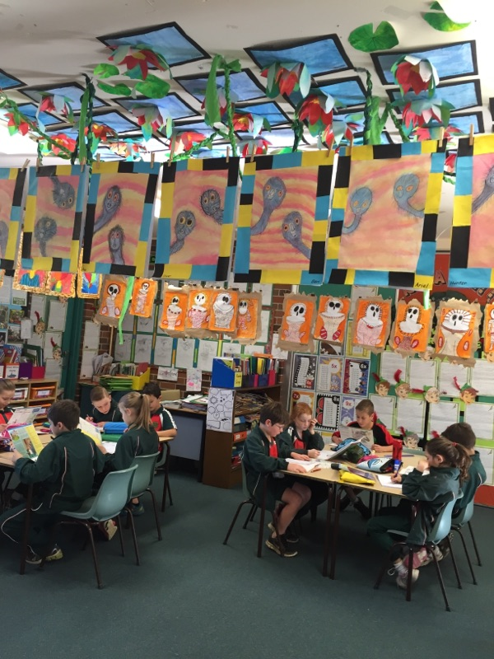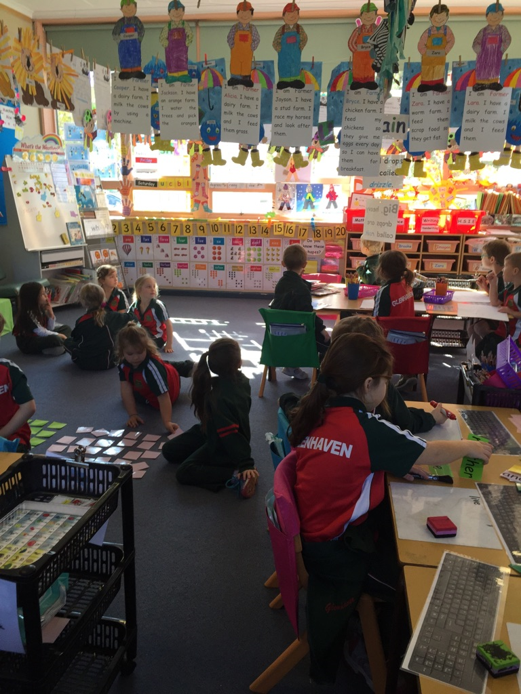
Expectations Non Classroom and Routines.
 | Respect | Responsibility | Personal Best
Moving around the school | Walk quietly at all times  Use polite manners when entering and exiting classrooms | Move safely  Be at the right place at the right time  Stay to the left | Be prepared for your next lesson
Playground Hard surfaces | Follow and accept the rules of the games  Walk on hard surfaces  Be lined up by the end of the song.  Wear a hat to play | Move to and from playground safely  Play in the right place  Place rubbish in the bin  All food to be eaten, while sitting on hard surfaces  Play safely | Be an honest and fair player  Look after your personal belongings  Play quiet games in the morning and at recess
Playground Grass | Follow and accept the rules of the games  Respect the school environment  Be lined up by the end of the song  Wear a hat to play | Move to and from playground safely  Play in the right place  Play safely | Be an honest and fair player  Look after your personal belongings
Canteen | Be considerate of others  Follow instructions of canteen staff  Wait your turn  Use good manners | Walk to the canteen  Wait patiently in the right line  Purchase for yourself only | Know what you want to buy  Have your money ready
Toilets | Respect the privacy of others  Consider the next user  One person at a time in the cubicle | Flush the toilet  Be hygienic  Leave the area clean and tidy  Turn off taps | Use the toilet before school and at breaks  Wash your hands
Assembly | Actively listen to the presenter  Applaud and respond sensibly  Stand and sit quietly  Stand with your hands by your side to sing the national anthem | Enter and leave calmly and quietly  Keep aisles clear  Keep hands and feet to yourself | Participate with pride  Celebrate the achievements of others
Bus Bay | Follow all school rules | Walk directly to bus bay  Sit and watch for your car  Leave all belongings in your bags  Stay in area until picked up  Refrain from play  Wait at the gate for teacher | Know your travel safety rules and “stranger danger”  Take all your belongings with you when you leave
PSSA | Be a team player  Display good sportsmanship  Respect all officials and their decisions | Be a team player  Display good sportsmanship  Respect all officials and their decisions | Always try your best  Be a good sport and play fairly
Excursions | Wear correct uniform  Use inside voices  Respect other community members  Use manners | Make safe choices  Come prepared  Bring notes and money in on time | Learn as much as you can  Participate to the best of your ability  Ask sensible questions
Computer Lab | Treat all equipment with care  Log out after use  Work cooperatively | Follow the computer usage rules  Use internet appropriately  Follow the code of conduct  No food or drink | Use time wisely  Follow procedures carefully
Office | Enter and leave quietly  Wait your turn  Use your manners | Walk directly to and from the office  Accept the responsibility of delivering the message confidently | Know why you are at the office  Say the message clearly
Library/Games Room | Use quiet voices  Handle books and equipment with care  Listen to the library monitors  Leave your area tidy | Wait in the right place  Take all your belongings  Know your computer day | Use your time wisely  Be aware of others  Assist when necessary
 | CR Listen actively and follow instructions  Speak positively, showing consideration to others  Appreciate differences and be inclusive | Look after your belongings and be prepared  Take ownership of your actions  Have responsibility for a safe learning environment | Aim high and take risks  Be resilient and show initiative  Reflect and learn from mistakes
 | Follow and accept the rules of the equipment  Respect playground equipment by treating it correctly  Taking your turn by waiting patiently  Wear a hat to play  Only enter the slide from the top platform | Move to and from playground safely  Play in the right space  Walk around the equipment area, even when not playing on it  Maximum of 4 people on a platform  Exit the platform by the stairs, pole or slide  One person on each slide at a time  Stay on the one side of the climbing nets | Be an honest and fair player  Look after your personal belongings  Be opatient  Speak nicely to each other

Inclusive, Respectful and Engaging Schools.
At Glenhaven Public School we are committed to creating engaging ad effective classrooms, and an inclusive and safe school community. Students and staff have the right and responsibility to engage in positive and respectful relationships based on valuing the interests, abilities and diversity of others. All students and staff have the right to be treated fairly and with dignity in an environment free from intimidation, harassment, victimization, discrimination and continued disruption.
All students and staff have a right not to be subjected to racism or discrimination, including that based on sex, race, religion, disability, sexual orientation, or gender identity.
At Glenhaven all children have a right to an education where students can access and fully participate in learning.
Supporting and enabling positive student behavior is essential for quality learning, as well as the wellbeing and safety of all students and staff. Inclusive practice will be embedded in all aspects of school life and be supported by school culture and everyday practice.

Restrictive Practices
Sometimes, to help keep a student, or others, healthy and safe at school, we need to limit or restrict some of their actions. These limits are called restrictive practices.
A restrictive practice is any action that has the effect of restricting the rights or freedom of movement of a person, with the primary purpose of protecting the person or others from harm.
The use of restrictive practice is monitored, proportionate to the possible risks of harm, and reduced and eliminated over time, where possible. At Glenhaven Public School we will carefully consider and balance the rights and safety of other people impacted by the behavior and use of restrictive practice.
Restrictive practices are only to be used:
- In the way they have been recommended or prescribed by an external medical practioner, allied health professional or external behavior support practioner.
- As a last resort, after less restrictive approaches and strategies hae been used
- When planned in consultation with the student, where possible and parents/carers in line with the 6 principles for decision making.
- With consent from parents/carers.
In an emergency or crises, it may be appropriate to use a restrictive practice to protect a student from a real and immediate risk or threat of injury to themselves or others and if there is no less restrictive way to respond.

Strategies for dealing with Unacceptable Behaviour in the Classroom

Note 1: Teachers will follow the step by step process monitoring students behavior at all times.
Note 2: Department of education suspension and expulsion guidelines will be enforced as required in managing student behavior.
Note 3: In cases of severe behavior, steps may be skipped with students being referred directly to Supervisor or Principal.

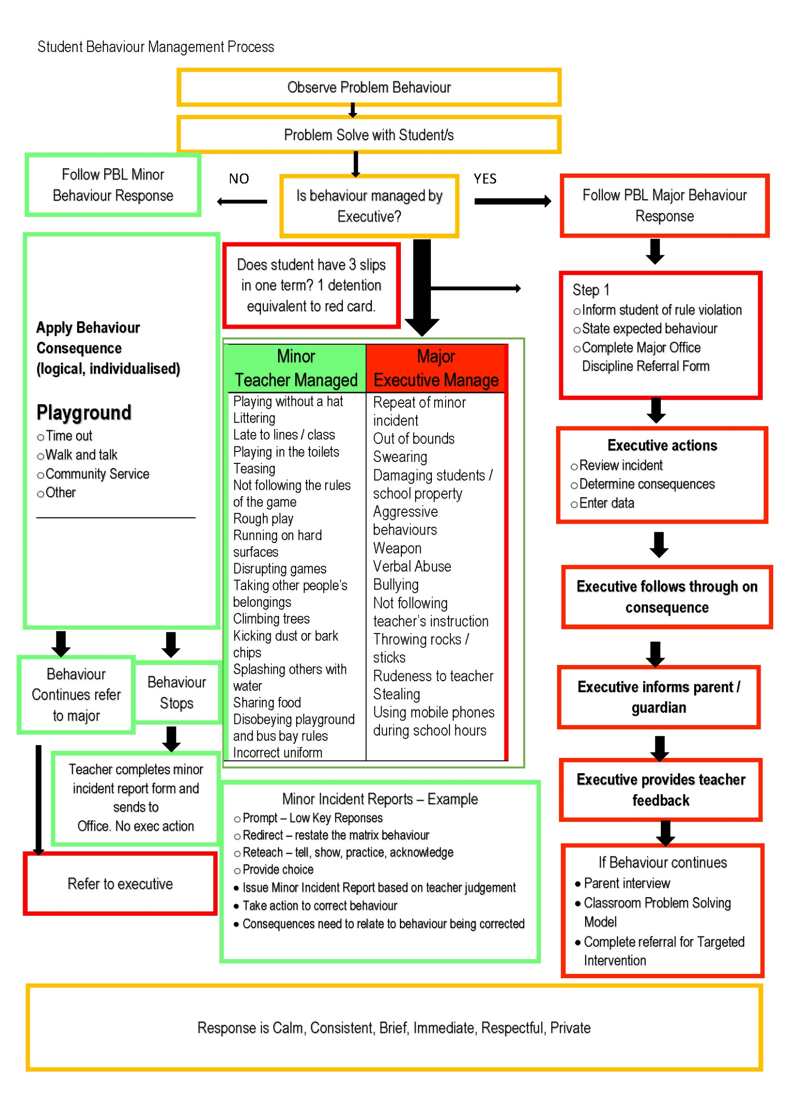

References

Department of Education. Behaviour Code for Students.

Department of Education Child Protection Education K-6.

Department of Education Student Discipline in Government Schools.

Department of Education Behavior and Participation

Department of Education Inclusive, Engaging Schools

Department of Education and Communities. Student Health in NSW Public Schools.

Department of Education and Communities. Wellbeing Framework for Schools.

Glenhaven Public School. Student Supervision Policy.

Glenhaven Public School. Anti-bullying Policy.

Glenhaven Public School. Student Code of Conduct for Device Usage.

Glenhaven Public School. Student Code of Conduct for PSSA and Players Contract.

